Assignment 5: CH5350

Abhijeet Mavi (BE14B001)

## Sample Simulations for ARMA models

model_aic=matrix(data=NA,nrow=3,ncol=100)  
model_order=matrix(data=NA,nrow=4,ncol=100)  
  
for (i in 1:100){  
print(i)  
yk=arima.sim(n=600,list(ar=c(0.2,0,0.1)))  
  
#For AR model estimation  
  
armod_aic={}  
for (j in 1:10){  
  
 armod=arima(yk,order = c(j,0,0))  
 armod_aic[j]=armod$aic  
 }  
model_aic[1,i]=min(armod_aic)  
model_order[1,i]=which.min(armod_aic)  
  
  
# #For MA model estimation  
  
mamod_aic={}  
for (k in 1:10){  
  
 mamod=arima(yk,order = c(0,0,k))  
 mamod_aic[k]=mamod$aic  
}  
model_aic[2,i]=min(mamod_aic)  
model_order[2,i]=which.min(armod_aic)  
  
#For ARMA model estimation  
  
armamod <- auto.arima(yk,seasonal = FALSE,d=0,D=0,max.p=10,max.q=10,start.p = 1,start.q = 1)  
  
model_aic[3,i] = armamod$aic  
  
model_order[3,i] = armamod$arma[1]  
  
model_order[4,i] = armamod$arma[2]  
}  
  
ar3_indices = which(model_order[1,]==3)  
  
ar3_aic<-apply(model_aic[,ar3_indices], 2, min)  
  
count_true<-length(intersect(ar3_aic,model_aic[1,]))  
  
print(count_true)

I took AR, MA and ARMA models, ranging from 0 to 10th order.

For N=600 samples, we see that we get AR(3,0) **16 times** out of 300 possible orders, for the given R script. I used **forecast** package to evaluate the arma model estimations using function **auto.arima()**.

For N=100 samples, we could only get **2 reasonable models** with AR(3,0) for AIC being the model ranker.

## Fitting a Seasonal Model

The seasonality in a model can be evaluated in 2 ways: in respect with **additive models** or **multiplicative models**

### Using stl() command

We see that the series is obviously seasonal in some way. Using **stl()**, we deduce the remainder for the decomposed series.

library('forecast')  
  
load('sarima_data.Rdata')  
  
#Part 1  
  
plot(yk)

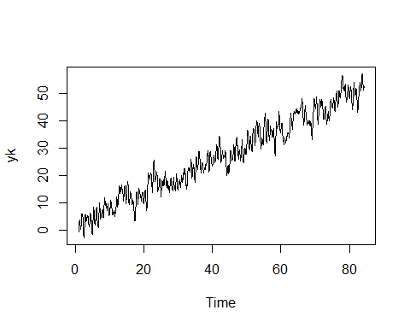

plot(stl(yk,'per'))

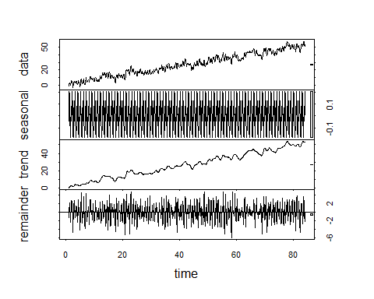

decom_yk <- remainder(stl(yk,'per'))  
  
plot(decom_yk)

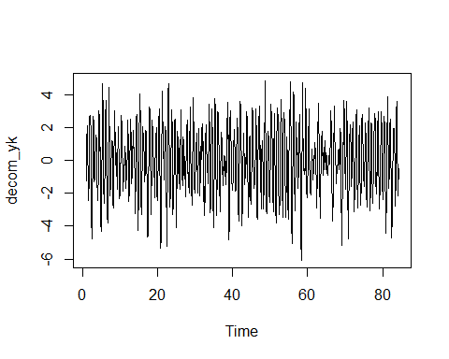

acf(decom_yk)

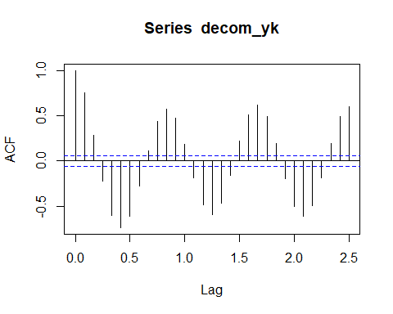

We see that the dcomposed series is seasonal with a period of about 10. We further fit a cosine wave using **lm()** and then check for its residuals.

tvec <- 1:1000  
  
decom_yk_seas <- lm(decom_yk ~ I(sin(2*pi*(1/10)*tvec))+ I(cos(2*pi*(1/10)*tvec)))  
  
acf(decom_yk_seas$residuals)

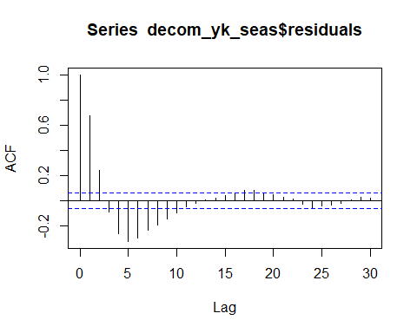

pacf(decom_yk_seas$residuals)

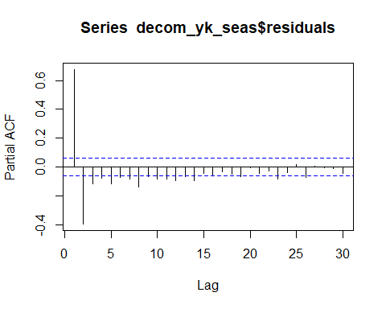

The residuals clearly show that the series is AR(2) with respect to the PACF plot. Further fitting the AR(2) model

ar2mod <- arima(decom_yk_seas$residuals,order=c(2,0,0))  
  
ar2mod

##   
## Call:  
## arima(x = decom_yk_seas$residuals, order = c(2, 0, 0))  
##   
## Coefficients:  
## ar1 ar2 intercept  
## 0.9434 -0.3940 0.0010  
## s.e. 0.0290 0.0291 0.0592  
##   
## sigma^2 estimated as 0.7116: log likelihood = -1249.31, aic = 2506.63

acf(ar2mod$residuals)

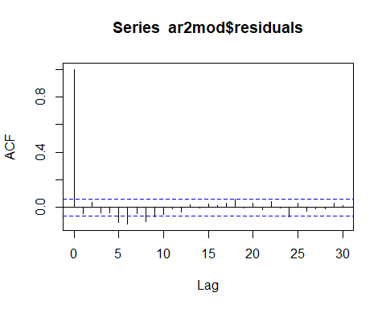

We see that the residuals of AR(2) model satisfy underfit overfit criteria with respect to the ACF of the plot. Hence, the final series is:

$$v[k]=0.002798sin(0.2πk)−1.374654cos(0.2πk)+0.9434*v[k−1]−0.3940*v[k−2]+e[k]$$

### Using SARIMA Models Now,

#Part 2  
  
acf(yk)

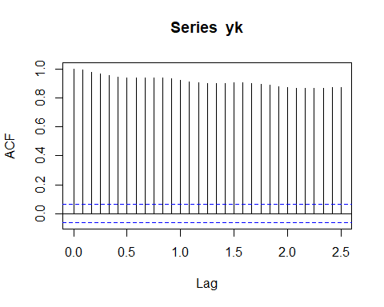

We see that the series clearly needs differencing. SO, after differencing once, we look at the acf of residuals and notice its periodicity of approximately 10.

diff_yk <- diff(yk)  
  
acf(diff_yk)

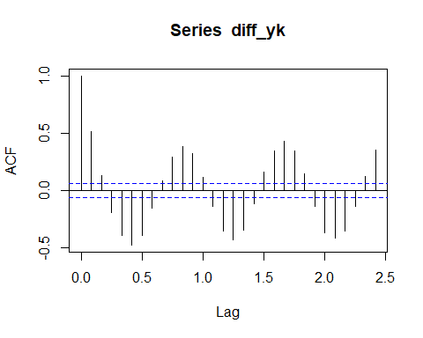

I then simulated various SARIMA models with periodicity and checked which one satisfies underfit and overfit arguements. I concluded that AR(2) with SARIMA(1,1) is the best model. The ACF and PACF plots show the same.

sarimamod=arima(yk,order=c(2,0,0),seasonal=list(period=10,order=c(1,0,1)))  
  
acf(sarimamod$residuals)

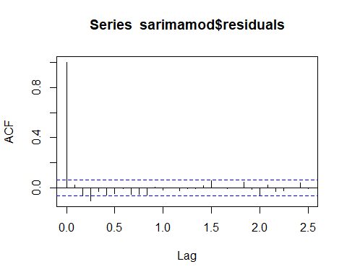

pacf(sarimamod$residuals)

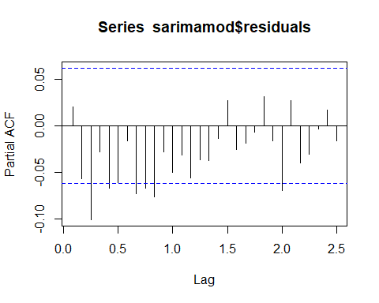

$$∇v[k]=1.3031v[k−1]−0.3101v[k−2]+e[k])*(0.9988v[k−10]−0.9648e[k−10])$$

## Maximum Likelihood Estimation

For a given sample set, suppose we have $X_{i}$ ranging from 1 to N, with $X_{n}$, for some n being the maximum value of the set. So,

$$P(X_{i}|θ)=\frac{1}{θ}$$

Assuming the events of picking a sample is independent.

$$f(X_{1},X_{2},X_{3}.....,X_{N}|θ)=\frac{1}{θ^{N}}$$

$$l(θ|N)=\frac{1}{θ^{N}}$$

$$L(θ|N)=−Nlogθ$$

NOw the log-likelihood function will take it’s maximum value at the minimum value of $θ$. $θ$ should atleast be greater or equal to the maximum value of sample set $X_{n}$.

$$\overset{^}{θ}=X_{n}$$

load('mle_unif.Rdata')  
  
max(xk)

## [1] 1.966975

theta = seq(max(xk),101, by=1)  
  
L_theta={}  
  
for (i in 1:100) {  
   
 L_theta[i] = -100*(log(theta[i]))-(sum(xk)/theta[i])  
  
}  
plot(L_theta)

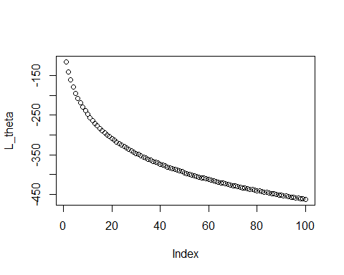

One can deduce the same from the graph of likelihood vs $θ$.

Furthermore, we know that bias $Δθ=E(\overset{^}{θ})−θ_{0}$, with $θ_{0}$ being the truth. We see that for any x in [0, $θ$] such that $x>= X_n, $the probability of this sample space over N samples become $P_{θ}=(\frac{x}{θ})^{n}.$

$$E(\overset{^}{θ})=E(X_{n})=\int_{0}^{θ}{P_{θ}}(X_{n}>=x)dx$$

$$E(X_{n})=\int_{0}^{θ}{1}−(\frac{x}{θ})^{n}dx=θ−\frac{θ}{N+1}=\frac{Nθ}{N+1}$$

Hence,

$$Bias=Δθ=E(\overset{^}{θ})−θ_{0}=\frac{Nθ}{N+1}−θ=\frac{−θ}{N+1}$$

Rather, if the distribution was uniform over $[0,θ),$ we would have only got a limit tending to the maximum value $X_{n}$ for $\overset{^}{θ}$ which is not a right estimate for our subsequent bias calculation since this limit could become far away from the real $X_{n}.$ In order to solve this ambiguity, one can take large number of samples, then using the principles of consistency, one can say that the limit will tend to $X_{n}.$

## Fisher’s Information

For a given probability distribution function $f(y|θ)$, we evaluate likelihood $l(θ|y)$ which can be considered equal to the the probability distribution function.

In order to estimate the most efficient estimator, the estimator should satisfy the following condition,

$$\frac{S(θ;y)}{I(θ)}+θ=θ^{*}$$

In the above equation $^* $should only be a function of y, that is the data instants. With that in mind, let’s evaluate the two conditions given.

### $λ$ is the parameter

$$f(λ)=l(λ)=λe^{−λy}$$

$$L(λ)=log(l(λ))=log(λ)−λy$$

$$S(λ;y)=\frac{∂L}{∂θ}=\frac{∂(log(λ)−λy)}{∂λ}=\frac{1}{λ}−y$$

$$I(λ)=−E\left((\frac{∂L}{∂θ})^{2}\right)=−E(\frac{−1}{λ^{2}})=\frac{1}{λ^{2}}$$

This implies,

$$\frac{S(θ;y)}{I(θ)}+θ=λ−λ^{2}y+λ=2λ−λ^{2}y=θ^{*}$$

Clearly, the most efficient estimator of $λ$ is a function of parameter itself, hence, it is not possible to determine the efficient estimator for $λ.$ Let’s try for a modified version of the same parameter.

### $\frac{1}{λ}=k$ is the parameter

$$f(k)=l(k)=\frac{e^{−y/k}}{k}$$

$$L(k)=log(l(k))=\frac{−y}{k}−log(k)$$

$$S(k;y)=\frac{∂L(k)}{∂k}=\frac{y}{k^{2}}−\frac{1}{k}$$

$$I(k)=−E\left(\frac{∂^{2}L}{∂k^{2}}\right)=−E\left(\frac{−2y}{k^{3}}+\frac{1}{k^{2}}\right)=\frac{1}{k^{2}}$$

This happens because since the process is white noise, so that makes $E(y)=\frac{1}{λ}=k$ since y is plotted on an exponential distribution. Now,

$$\frac{S(k;y)}{I(k)}+k=k^{*}=−k^{2}\left(\frac{1}{k}−\frac{y}{k^{2}}\right)+k=y$$

As one can see, $k^{*}$ is purely a function of y, and hence it is the most efficient estimator for the given estimator.

## Variability of Sample Mean

For the vaiability of sample mean ($σ_{\overline{y}}^{2}$), we have for stationary data that has N realisations,

$$σ_{\overline{y}}^{2}=E((\overline{y}−E(\overline{y}))^{2})=E((\frac{1}{N}Σ_{k=0}^{N−1}y[k]−μ_{y})^{2})=E((\frac{1}{N}Σ_{k=0}^{N−1}(y[k]−μ_{y}))^{2})$$

$$σ_{\overline{y}}^{2}=\frac{1}{N^{2}}E(Σ_{k=0}^{N−1}(y[k]−μ_{y}))^{2})+\frac{1}{N^{2}}E(Σ_{n=1}^{N}Σ_{m=1}^{N}(y[n]−μ_{y})(y[m]−μ_{y}))$$

The first term in the above expression can be easily seen as the $\frac{σ[0]}{N}$, the second term where n is not equal to m can be shown as the auto-covariance function.

As, $σ[l]=σ[−l]$ for a stationary process, so it will suffice us to only take one side of the double summation, when $n<m$.

$$σ_{\overline{y}}^{2}=\frac{σ[0]}{N}+\frac{2}{N^{2}}E(Σ_{n=0<m}^{N−1}(y[n]−μ_{y})(y[m]−μ_{y}))$$

Now, let’s take $|n−m|=l$ as the lag for ACVF. For, l=1, we will see $σ[1]$ terms N-1 times, $σ[2]$ terms N-2 times and so on for $σ[l]$, we will see it N-l times. We can rewrite the above expression as

$$σ_{\overline{y}}^{2}=\frac{σ[0]}{N}+\frac{2}{N^{2}}E(Σ_{l=1}^{N−1}(N−l)σ[l]$$

Hence,

$$σ_{\overline{y}}^{2}=\frac{1}{N}(σ[0]+2E(Σ_{l=1}^{N−1}(1−\frac{l}{N})σ[l]$$

N=5000 #no. of samples  
  
#Generic method to calculate variance of sample mean estimator  
  
mean_yk={}  
  
for (i in 1:N){  
   
 yk<-arima.sim(model=list(ma=0.4,order=c(0,0,1)),n=10000)  
 mean_yk[i]=mean(yk)  
}  
  
hist(mean_yk)  
  
var_1={}  
for (i in 1:5000){  
 var_1[i]=(mean(mean_yk)-mean_yk[i])^2  
}  
  
var_1=sum(mean_yk)/(N-1)  
  
#Calculation using the proved expression  
  
acvf_data = acf(yk,lag.max = 10000, type='cov')  
  
acvf_yk = acvf_data$acf  
  
sum_term=0  
  
for (i in 2:10000){  
   
 sum_term=sum_term+((1-(i/10000))*acvf_yk[i])  
}  
  
var_2 = (1/10000)*(acvf_yk[1]+(2*sum_term))

The code written above simulates the given MA(1) model and I have evaluated variance with both the methods. Variance with the generic method comes out to be **4.149214e-05** and with our expression proved above, we get a variance of **1.728528e-05.** The values have a different scale altogether, but still are comparable to an extent that both are converging to 0 which is the general case for sample mean estimator. The variance would ideally converge to 0 as we increase the sample size to infinity.